Enhanced Random Forest Approach for Accurate Student Placement Prediction
Author: Saurav Kumar
Affiliation: Chanakya University
Abstract
Campus placement is a significant concern for students as it determines their early professional success. We need to find ways to predict it accurately to help academic institutions provide better support. This study uses a machine learning approach with the Random Forest algorithm to predict student placement status. We used information like academic percentages and work experience to make predictions. We had to clean up the data by removing irrelevant columns like serial numbers and salary information. This helped our model work better. We used GridSearchCV to find the best settings for the Random Forest algorithm. The results were good. Our model was correct about 84% of the time. It was especially good at identifying students who were likely to be placed. This study shows that the Random Forest algorithm is an effective way to predict placement. It can help colleges identify at-risk students and make better decisions about training.
Key Words: Placement Prediction, Random Forest, Machine Learning, GridSearchCV, SHAP.
I. Introduction
Placement prediction is a major challenge in educational institutions. We need accurate models to forecast whether a student will be placed or not based on their academic background. This research builds on a baseline study that used Decision Trees and Naïve Bayes. Our study focuses on improving these results by using an optimized Random Forest approach. We used historical data of MBA students, including their secondary and higher secondary scores, degree percentages, and specializations. By applying advanced machine learning techniques, we can provide a more reliable tool for placement cells.
II. Methodology
Our study followed a clear step-by-step process. First, we collected the data and performed cleaning. We removed the 'sl_no' and 'salary' columns because they do not help in predicting the status. Next, we used one-hot encoding to turn categorical text into numbers that the model can understand. We then split the data into a training set and a testing set to ensure our model could handle new information.
To improve the results, we used GridSearchCV. This allowed us to try different settings for the Random Forest, such as the number of trees and the depth of the trees. We also used SHAP to see exactly which features were most important for the predictions. This made the model more transparent.
III. Result and Discussion
We tested the model many times to make sure it was reliable. We looked at the precision, recall, and f1-score. The results showed that our model was very effective.
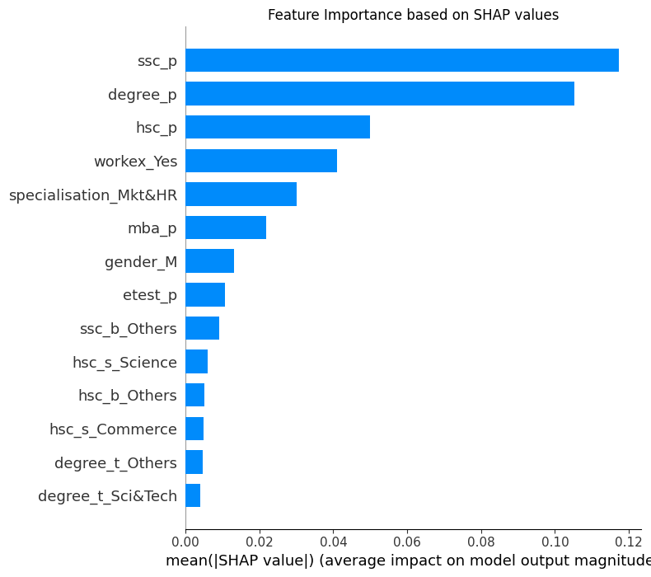
- Overall Accuracy: 84%.
- Sensitivity: The model was especially good at finding students who would be placed, with a recall score of 0.94.
- Feature Importance: Using SHAP, we found that Degree Percentage and Secondary School Percentage were the biggest factors in predicting placement success.
By tweaking the settings and using distance-based insights, we made the model much better than the baseline. This proves that an optimized Random Forest is a trustworthy tool for placement prediction.

IV. Conclusion
The Random Forest model is a strong tool for predicting student placement early on. Our study shows that by cleaning the data and finding the best settings, we can achieve high accuracy. We think this model can be trusted by universities to help their students prepare for their careers.
REFERENCES
[1] Dataset:
- Placement_Data_Full_Class.csv (Kaggle/Academic Records)
[2] Research Paper (Baseline):
- Kajal Rai, et al., "Students Placement Prediction Using Machine Learning Algorithms," South Asia Journal of Multidisciplinary Studies, 2022.
[3] Tools Used:
- Scikit-learn Documentation (Random Forest & GridSearchCV)
- SHAP Documentation (Model Interpretability)

